Unisex Toilet Sign | Toilet SignsUnisex Toilet Sign | Toilet Signs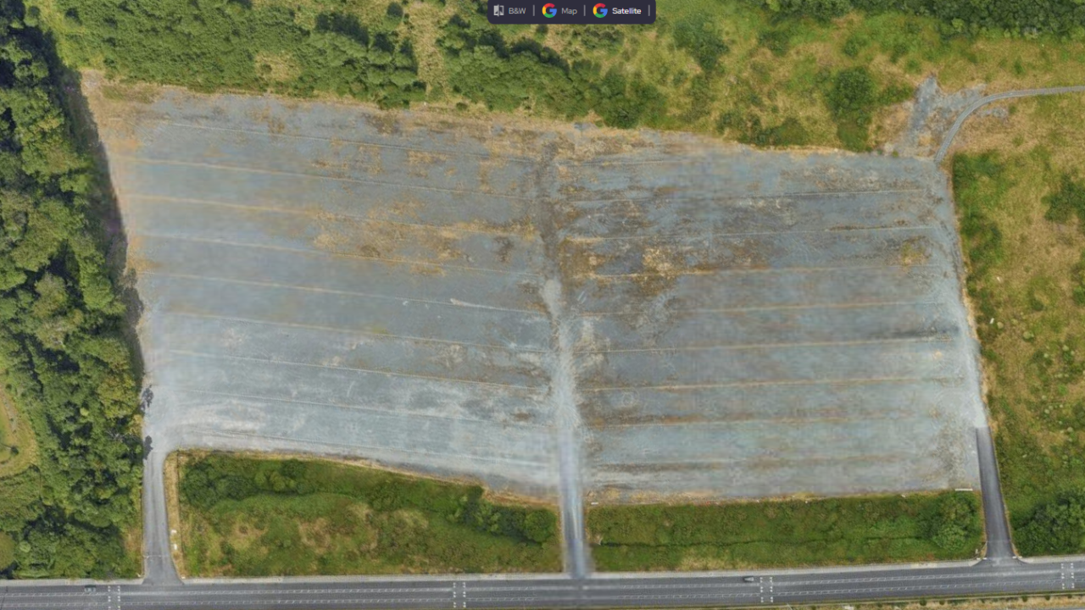48 700+ Robinet Illustrations, graphiques vectoriels libre de droits et  Clip Art - iStock****

**25 : Non-Club**

**26 : Non-Club**

**22: Non-Club**

**17: Fiat**

**27: Bus**

**4: Brooks**

30m

**38: Selling cars**

**30: Non-Club**

**29: Non-Club**

**28: Non-Club**

**8: Bikes**

**44: On the day**

**45: On the day**

**43: On the day**

**42: On the day**

**41: On the day**

**40: On the day**

**39: On the day**

**37: On the day**

**36: On the day**

**35: On the day**

**34: On the day**

**33: On the day**

**32: On the day**

**31: On the day**

Compound

**: On the day**

**16: MG**

25m

**23 : Non-Club**

**24 : Non-Club**

**21 : Non-Club**

**20: Non-Club**

**18: HRCA 19: TVR**

35m

**: On the day**

**: On the day**

**: On the day**

35m

25m

32m

10m

**15: Carlow**

**14: 500**

35m

35m

35m

40m

**2: Rusty**

**3: IVVCC**

**IVVCC**

**IVVCC / Other**

25m

37m

35m

PRODUCTION

**7: RS**

**6: Lancia**

**5: Garda**

**10: Citroen**

**9: Mercedes**

**13: Opel**

**12: Alfa**

35m

**11: Mini**

50m

**1:**

**Triumph**

AUTOJUMBLE

FUNFAIR

FOOD & SNACK

AXA

Event control

STAGE

**❷**

**❶**

**❹**

**❸**

**❻**

**CHROME THE CLASSIC CAR & BIKE SHOW, 2nd JULY 2023**

**❺**

C

B

A

Blood bikes

Car stands

Lakers stand

AXA Insurance stand

Steam Academy

National Flight Centre

Event control

Vans (Roxy & Foxy)

Production

Generators

Catering sink

Picnic benches

❶

Security

Medics

Fencing

Inflatable archway

Gazebo

Toilets

A

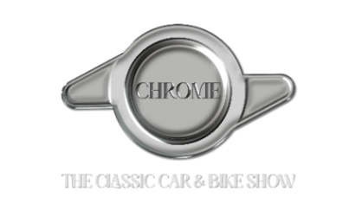

Pedestrian entrance

Displayed vehicles entrance

Exit

On-site driving way

Bus Stop

B



C



48 700+ Robinet Illustrations, graphiques vectoriels libre de droits et  Unisex Toilet Sign | 